- \Operation\Tube filling\ Dosing\Tube filling - dosing – shut-off
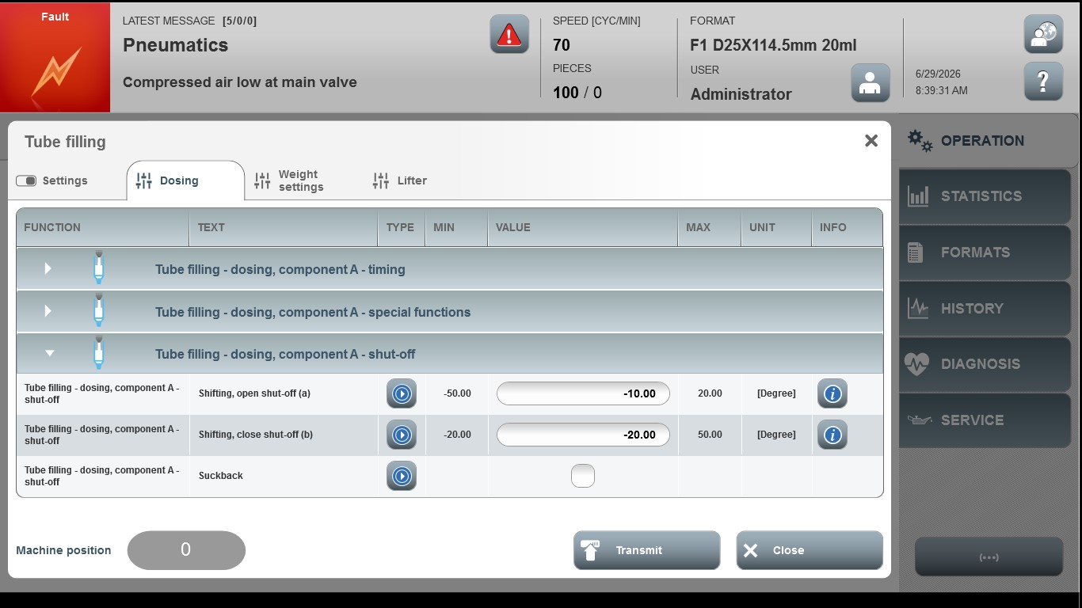
Acceptance criterion | Limits | Pass / Fail: Dev-No. | Date | Initials
Screen matches screenshot | N / A
Shutting, open shut-off (a) | -50…20
Shutting, close shut-off (b) | -20…50

